AI Policy Impact Simulator
for Indian Public Policy
Simulating the Differential Impact of Indian Government Policies on Demographic Groups using a Knowledge-Graph-Grounded, Multi-Agent Persona Simulation, Calibrated with Causal Inference
Project Proposal
Domain: Artificial Intelligence | Focus Areas: GraphRAG · Multi-Agent LLM Simulation · Causal Inference

1. Executive Summary
Indian public policy, whether it is a Union Budget announcement, a farm law, a fuel subsidy change, or a welfare scheme like PM-KISAN or Ayushman Bharat, never lands the same way on every citizen. Its effects differ sharply by state, by rural versus urban residence, by social category (SC/ST/OBC/General), by income group, by occupation (farmer, informal-sector worker, salaried), and by gender. Today, this differential impact is understood only in aggregate, and usually only well after a policy has been rolled out.
This project proposes an AI Policy Impact Simulator for India built from four deliberately separated components, chosen to keep the system both realistic and computationally affordable. First, a knowledge graph is built once from real Indian policy and demographic data using a GraphRAG-style, LLM-based extraction step — the same underlying mechanism popularised by swarm-simulation engines such as MiroFish, used here strictly to build the graph, not to run the simulation itself. Second, a causal inference layer uses that graph's demographic segmentation to estimate how policies have historically, causally affected each subgroup. Third, a lightweight, non-LLM Monte Carlo / agent-based simulation engine uses those causal effects to project outcomes for any hypothetical policy setting, cheaply and at scale. Fourth, a reinforcement learning optimizer treats this cheap simulation as its environment, searching the space of policy settings to actively recommend near-optimal choices against a stated objective (e.g., minimise inequality, maximise the outcome of the worst-off group, stay within budget) — rather than only predicting the effect of a policy the user already specified.
Keeping the token-heavy, LLM-driven mechanism confined to the one-time knowledge graph build, rather than running thousands of LLM agent personas through many simulated rounds, keeps the system cheap enough to run the thousands of simulation and RL iterations that real policy optimisation requires.

2. Problem Statement
There is no accessible, India-specific tool that lets policymakers, researchers, journalists, or citizens simulate how a proposed Indian government policy will differentially affect distinct demographic and regional groups before the policy is enacted. Existing analysis is largely aggregate (national or state-average impact), retrospective (measured years later through NSSO/PLFS rounds), or confined to specialist government modelling units.
Concretely, the project addresses three linked questions, using India as the setting:
- How has a given Indian policy lever (e.g., MSP change, GST rate change, LPG subsidy change) historically, causally affected a specific outcome (income, consumption, employment, healthcare access) for a specific demographic or regional subgroup?
- If a new or modified policy is introduced (e.g., a new MSP for wheat, an expanded PM-KISAN transfer, a GST slab change), what outcome and what public reaction can we project for each subgroup, including uncertainty?
- Given a stated objective (e.g., minimise inequality, protect the worst-off subgroup, stay within a fixed budget), what policy setting should actually be recommended — not just evaluated after the user picks one, but actively searched for and suggested by the system?

3. Current Issue
Indian policy design and rollout are disconnected from granular, subgroup-level evidence at the moment decisions are made. Recent history illustrates the cost of this gap:
- The 2016 demonetisation and the 2017 GST rollout had sharply different effects on the informal sector, cash-dependent rural workers, and small traders compared to the formal, urban economy — effects that were debated in aggregate for months before subgroup-level data became clear.
- The 2020 farm laws produced strong, geographically concentrated reactions (notably in Punjab and Haryana) that were not well anticipated by aggregate, national-level economic modelling.
- Welfare scheme rollouts (e.g., PM-KISAN, Ayushman Bharat, Ujjwala Yojana) show large gaps between intended and actual uptake across states and social categories, often discovered only through post-hoc NSSO/PLFS or NFHS survey rounds, years after launch.
- Average, national-level metrics (GDP growth, aggregate inflation) can look positive while masking harm to specific groups — e.g., rural consumption slowdowns hidden behind urban-led growth.
- Feedback loops are slow: Parliamentary committee reports, CAG audits, and academic causal studies typically arrive one to five years after a policy takes effect.

4. Existing Solutions & Related Work
Several tools and approaches exist in the Indian and global context, but none combine graph-grounded agent simulation with causal calibration in an accessible way:
Solution / Approach | What it does | Gap for the Indian context
NITI Aayog dashboards (SDG India Index, etc.) | Track state-wise progress on development indicators. | Descriptive, not predictive or simulation-based; cannot test a new hypothetical policy before rollout.
PRS Legislative Research | Summarises and tracks bills and their provisions. | Explains what a bill says, not how different groups will be affected in practice.
Union Budget / Economic Survey modelling (Finance Ministry, RBI) | Produce aggregate macroeconomic projections (growth, inflation, fiscal deficit). | National-average focus; rarely broken down by caste category, informal-sector status, or district.
Academic causal studies on Indian policy (demonetisation, GST, MGNREGA impact papers) | Rigorously estimate the causal effect of one specific, already-implemented policy. | One-off and retrospective; cannot project a new, not-yet-implemented policy scenario.
Global swarm-simulation engines (e.g., MiroFish, built on GraphRAG + persona agents) | Generate large numbers of LLM personas from a knowledge graph and simulate their reactions to an event. | Not tailored to Indian demographic structure, government data sources, or policy vocabulary; general-purpose, not causally calibrated.
Table 1: Existing approaches and the gap this project addresses.

5. Current Workflows
The typical process today for assessing an Indian policy's demographic impact looks like this:
- A ministry or state government drafts a policy or scheme (e.g., a new farm procurement rule, a subsidy scheme, a tax slab change).
- The Finance Ministry, NITI Aayog, or a departmental economics division produces an aggregate cost/impact estimate, often over weeks.
- The policy is passed and rolled out; implementation data trickles in through state-level administrative records of uneven quality.
- Independent researchers publish causal studies once NSSO/PLFS, NFHS, or Census-linked data becomes available — typically one to five years later.
- Media, opposition parties, and advocacy groups interpret and debate distributional impact largely through anecdote and delayed survey data, long after the policy is already in force.
This workflow is slow, fragmented across ministries and research institutions, and offers no interactive way to stress-test a policy across India's diverse demographic and regional landscape before it is committed to.

6. Limitations of Current Approaches
- Lack of subgroup granularity: Most tools report national or single-state breakdowns, not intersectional views (e.g., income decile × social category × rural/urban × state).
- Static, not exploratory: Existing models require a full ministry-level re-run for each new scenario; there is no lightweight way to test alternative policy designs interactively.
- No behavioural/reaction modelling: Aggregate economic models estimate income or consumption effects but rarely capture how citizens will actually behave — scheme uptake, compliance, protest, migration.
- Generic global tools aren't India-calibrated: Swarm-simulation engines built for other markets don't understand Indian administrative categories (state, district, caste category, BPL/APL status) or Indian data sources.
- Accessibility: Specialist software, restricted datasets, and steep learning curves keep rigorous modelling out of reach of students, journalists, civil-society organisations, and smaller state-level bodies.
- Uncertainty is rarely communicated: Point estimates are shown without confidence intervals or dissenting-agent shares, giving a false sense of precision.

7. Proposed Solution
The AI Policy Impact Simulator addresses these gaps with a four-part mechanism, deliberately split so that the expensive, LLM-driven step happens only once: a knowledge graph grounded in real Indian data (built using a GraphRAG-style mechanism, in the spirit of MiroFish, but for graph-building only), a causal-inference layer that estimates real subgroup effects using that graph's segmentation, a lightweight non-LLM simulation engine that projects outcomes for any policy setting, and a reinforcement learning optimizer that searches for and recommends good policy settings using the simulation as its environment.

7.1 Knowledge Graph Layer (India-grounded, GraphRAG mechanism, one-time build)
Ingest Indian policy documents (bill text, budget speeches, scheme guidelines) and structured datasets (Census of India, NSSO/PLFS, NFHS, SECC, RBI/MoSPI statistics) and use an LLM-based extraction step to identify entities — states/districts, social categories, occupations, income bands, schemes, policy levers — and the relationships between them. This is the same graph-building mechanism MiroFish uses (entity/relationship extraction into a structured graph), applied here purely as a one-time preprocessing step, not as part of the live simulation loop. The resulting graph defines the demographic segments and policy levers everything downstream operates on — for example, which states have the highest MGNREGA dependence, or which occupational groups are most exposed to a given GST slab.

7.2 Causal Inference Layer
Using the graph's segmentation, estimate the causal effect of each policy lever on relevant outcomes (income, consumption, employment, healthcare access) separately for each demographic subgroup, drawing on historical Indian policy episodes (demonetisation, GST rollout, MGNREGA expansion, MSP changes). Methods include Difference-in-Differences, Propensity Score Matching, and Causal Forests for heterogeneous treatment effects (via DoWhy / EconML). This produces a table of real, data-grounded effect sizes per subgroup, per policy lever.

7.3 Simulation Engine (lightweight, non-LLM)
Construct a synthetic population of statistical agents — not LLM personas — whose demographic mix matches real Census/NSSO/PLFS distributions. When a policy parameter is set, each agent's outcome is updated using the treatment effect estimated for its subgroup in the causal layer, plus realistic noise to reflect individual variation. Because this step is pure computation (no LLM calls per agent per round), it can be run thousands of times cheaply — a requirement for the optimisation step below.

7.4 Reinforcement Learning Policy Optimizer
Frame policy selection as a sequential decision problem: state = current demographic and economic conditions, action = a policy parameter setting (e.g., MSP level, GST slab, PM-KISAN transfer amount), reward = a user-defined social welfare function (e.g., minimise the Gini coefficient, maximise the outcome of the worst-off subgroup, or stay within a fiscal budget). An RL agent (e.g., trained via Proximal Policy Optimization using Stable-Baselines3) repeatedly queries the lightweight simulation engine as its environment and learns which policy settings best satisfy the objective — this is what lets the system actively suggest a policy, not just score one the user typed in.

7.5 Aggregation, Dashboard & API
Outcomes from both the simulation (for a user-specified scenario) and the RL optimizer (for a user-specified objective) are aggregated into subgroup-level projections — e.g., projected change in disposable income for small farmers in Punjab vs. Bihar — and surfaced through an interactive dashboard with state-wise maps, demographic breakdowns, uncertainty bands, and a 'suggest an optimal policy' view.

8. System Architecture
The diagram below shows the end-to-end flow. Indian data sources feed the knowledge graph builder (a one-time, LLM-based GraphRAG step) and the causal inference engine. The graph's demographic segmentation informs causal effect estimation. Those effects parameterize a lightweight, non-LLM simulation engine, which the RL optimizer repeatedly queries as its environment to search for good policy settings against a stated objective. Both a direct simulation result (for a user-specified scenario) and the RL-recommended setting are aggregated and served through the dashboard/API.
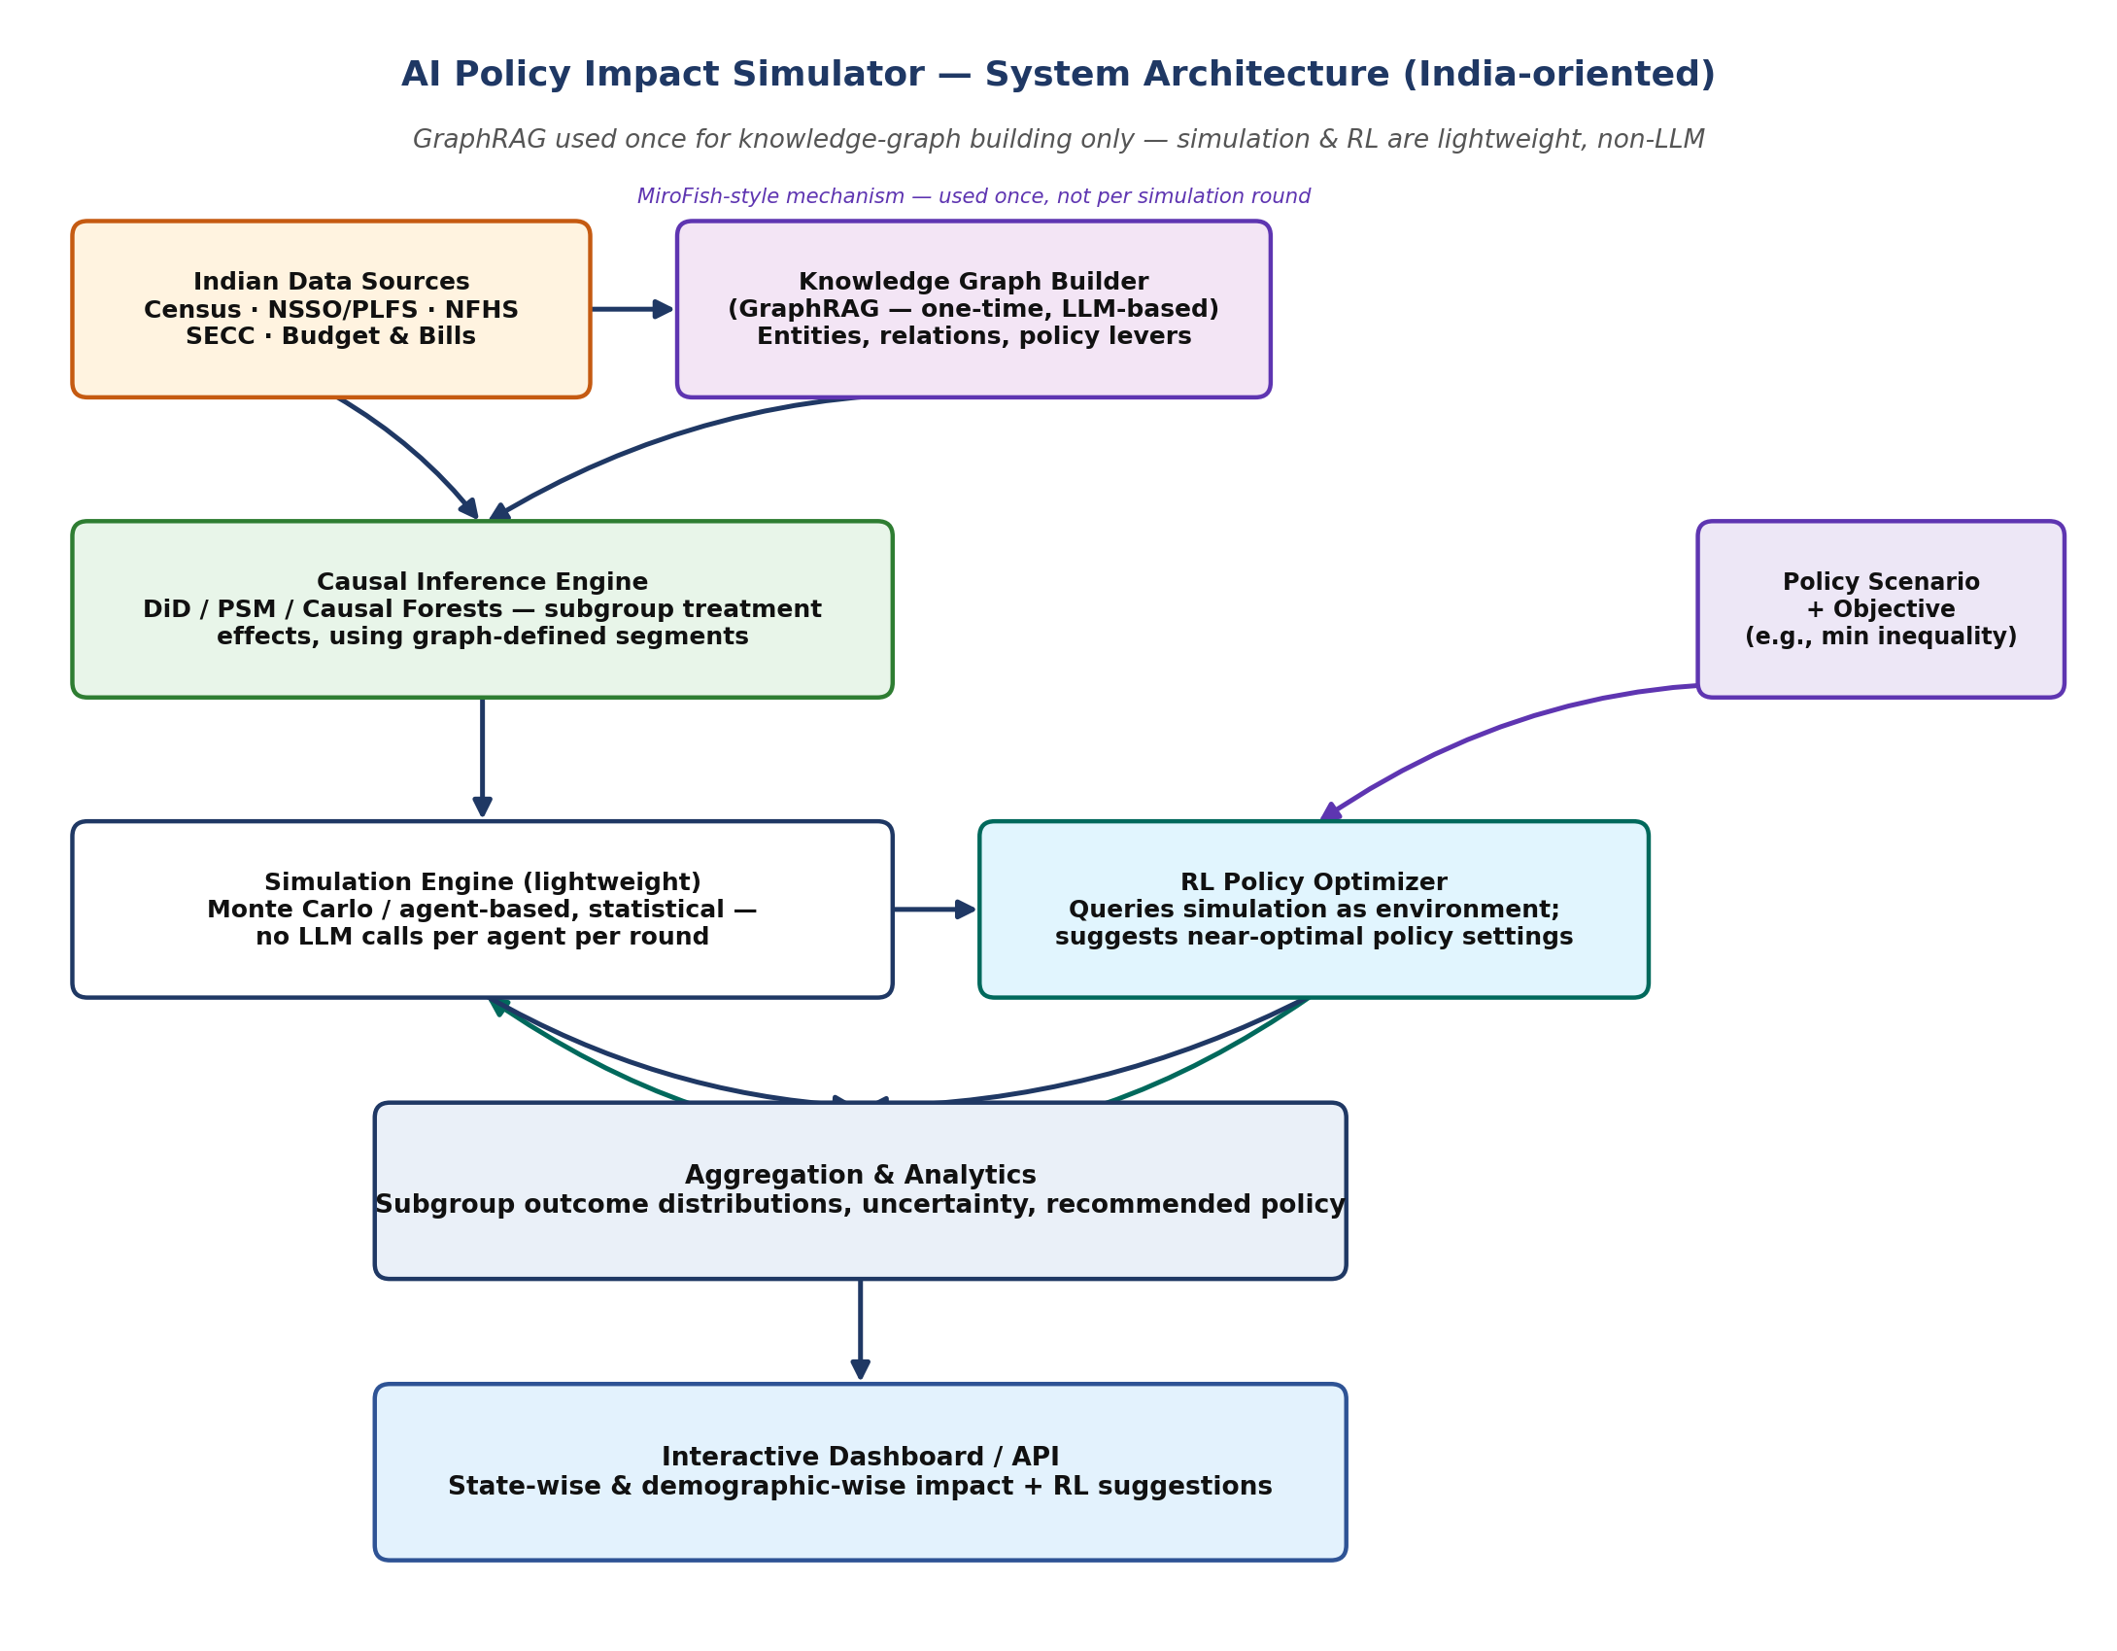
Figure 1: Layered architecture — GraphRAG is confined to the one-time knowledge-graph build; simulation and RL are lightweight and non-LLM.
Layer | Component | Responsibility
Data | Indian Data Ingestion | Pull and clean Census, NSSO/PLFS, NFHS, SECC, budget/bill text; construct panel and document corpora.
Knowledge (one-time) | Knowledge Graph Builder (GraphRAG) | LLM-based entity/relationship extraction, run once, to build the demographic-segment and policy-lever graph — the only LLM-heavy step.
Modelling | Causal Inference Engine | Estimate treatment effects (ATE and CATE) of policy levers on outcomes per subgroup, using the graph's segmentation, via DiD / PSM / Causal Forests.
Modelling | Simulation Engine (lightweight) | Non-LLM Monte Carlo / agent-based model applying causal effects to a synthetic population; cheap enough to run thousands of times.
Optimisation | RL Policy Optimizer | Repeatedly queries the simulation engine as its environment; searches the policy parameter space to recommend near-optimal settings for a stated objective.
Delivery | Aggregation, Dashboard & API | Aggregate simulation and RL outputs into subgroup projections; serve interactive, state-wise and demographic-wise views, including recommended policy settings.
Table 2: Component responsibilities by layer.

9. Proposed Technology Stack
Category | Tools / Sources
Knowledge graph / GraphRAG (one-time build) | Neo4j (or a lightweight graph DB); LLM-based entity/relation extraction via the Claude API
Causal inference | DoWhy, EconML, statsmodels (DiD / PSM / Causal Forests)
Simulation engine (lightweight, non-LLM) | Mesa (agent-based modelling) or a custom NumPy/pandas Monte Carlo engine
Reinforcement learning | Stable-Baselines3 (PPO), custom Gymnasium environment wrapping the simulation engine
Data processing | Python, pandas, NumPy
Backend / API | FastAPI
Frontend / Dashboard | Streamlit (fast prototype) or React + Plotly/Recharts, with an India state-wise map view
Indian data sources | data.gov.in, MoSPI (NSSO/PLFS), Census of India, NFHS, SECC, RBI statistics, PRS Legislative Research, Union Budget documents

10. Implementation Plan / Timeline
Phase | Duration | Deliverable
1. Scoping | Week 1 | Chosen Indian policy domain (e.g., MSP, GST, PM-KISAN), outcome variables, demographic/regional splits.
2. Data acquisition & cleaning | Weeks 2–3 | Cleaned Census/NSSO/PLFS panel data and policy document corpus.
3. Knowledge graph construction | Week 4 | One-time GraphRAG pipeline producing an entity-relationship graph from Indian data.
4. Causal inference model | Weeks 5–6 | Validated subgroup-level treatment effect estimates, using the graph's segmentation.
5. Lightweight simulation engine | Week 7 | Working, non-LLM simulator producing subgroup outcome distributions for any policy setting.
6. RL policy optimizer | Weeks 8–9 | Trained RL agent recommending near-optimal policy settings against a chosen objective.
7. Dashboard | Week 10 | Interactive interface: policy input, subgroup impact views, state-wise map, RL suggestions.
8. Evaluation & writeup | Week 11 | Validation report, documentation, and demo.
Table 3: Suggested 11-week implementation timeline (adjust to fit your actual project duration).

11. Evaluation Metrics
- Knowledge graph quality: precision/recall of extracted entities and relationships against a manually annotated sample of Indian policy documents.
- Causal model validity: out-of-sample prediction error on held-out historical periods; robustness checks (e.g., parallel-trends test for DiD).
- Simulation fidelity: backtesting — feed the simulator a past Indian policy episode (e.g., 2016 demonetisation, GST rollout) and compare its projected subgroup outcomes to what actually happened.
- RL optimizer performance: improvement in the chosen welfare metric versus a baseline (e.g., the real-world policy setting that was actually chosen, or a random/grid-search baseline).
- Usability: task-completion time and comprehension in a small user test (e.g., 'find an MSP level that keeps small-farmer income above X in both Punjab and Bihar').

12. Known Limitations & Risks
- The knowledge graph is only as good as the LLM extraction step and the source documents; extraction errors or gaps in coverage will propagate into how subgroups are segmented downstream.
- Causal estimates depend on the quality and coverage of Indian survey data, which varies by state and can lag by one to several years (NSSO/PLFS rounds, Census delays); unobserved confounders remain a standard risk of observational causal inference.
- The lightweight simulation is a statistical approximation, not a behavioural model of real decision-making — it captures magnitude and distribution of effects well, but not narrative or belief-driven reactions (e.g., protest dynamics), which would require a heavier, LLM-agent approach if ever added.
- India's demographic complexity (22+ official languages, wide rural-urban and interstate disparity, intersecting caste/income/occupation categories) means the graph's segmentation must be fine enough to avoid flattening real diversity into a few broad categories.
- The RL optimizer's 'recommendation' is only optimal with respect to the specific reward function chosen; different stakeholders value different objectives (equity vs. growth vs. fiscal cost), so the dashboard should let users adjust or compare objectives rather than present a single 'correct' policy.

13. Conclusion
By confining the token-heavy, GraphRAG-style mechanism to a one-time knowledge-graph build, and keeping the simulation and optimisation layers lightweight and non-LLM, this project gets the best of both worlds: a knowledge graph genuinely grounded in Indian policy and demographic data, and a simulation cheap enough to support real reinforcement-learning policy search. The result is a practical, India-specific tool that can both project the impact of a proposed policy and actively recommend better ones — from MSP and GST changes to welfare scheme design — with clear visibility into who benefits, who doesn't, and how confident the model actually is.

